

JPF-2 | Power feeder
10000256M
230/50/1

PARTS LIST


Walter Meier (TOOL) AG
Tämperlistr. 5
CH-8117 Fällanden
Switzerland
Phone +41 44 806 47 48
Fax +41 44 806 47 58
jetinfo.eu@waltermeier.com
www.jettools.com

P-10000256M 2012-06
JPF-2 Partlist and breakdown

JPF-2
MODEL： JPF-2 STAND ASSEMBLY
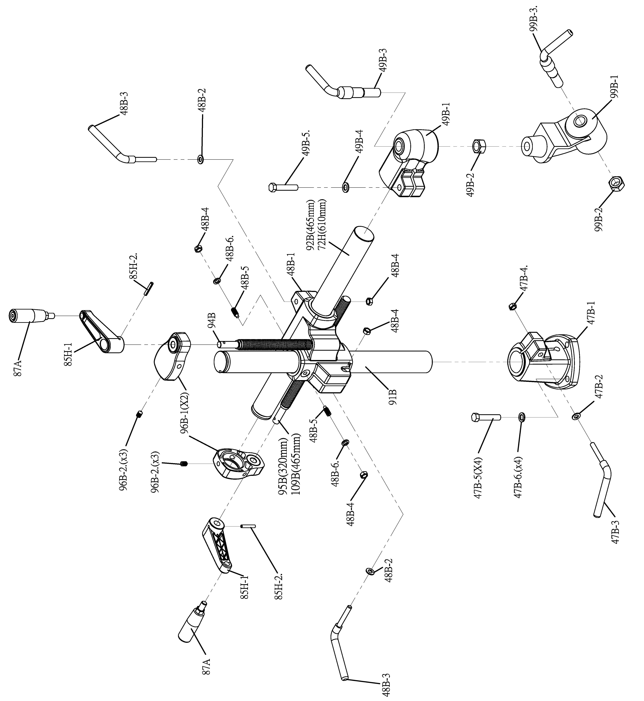

JPF-2
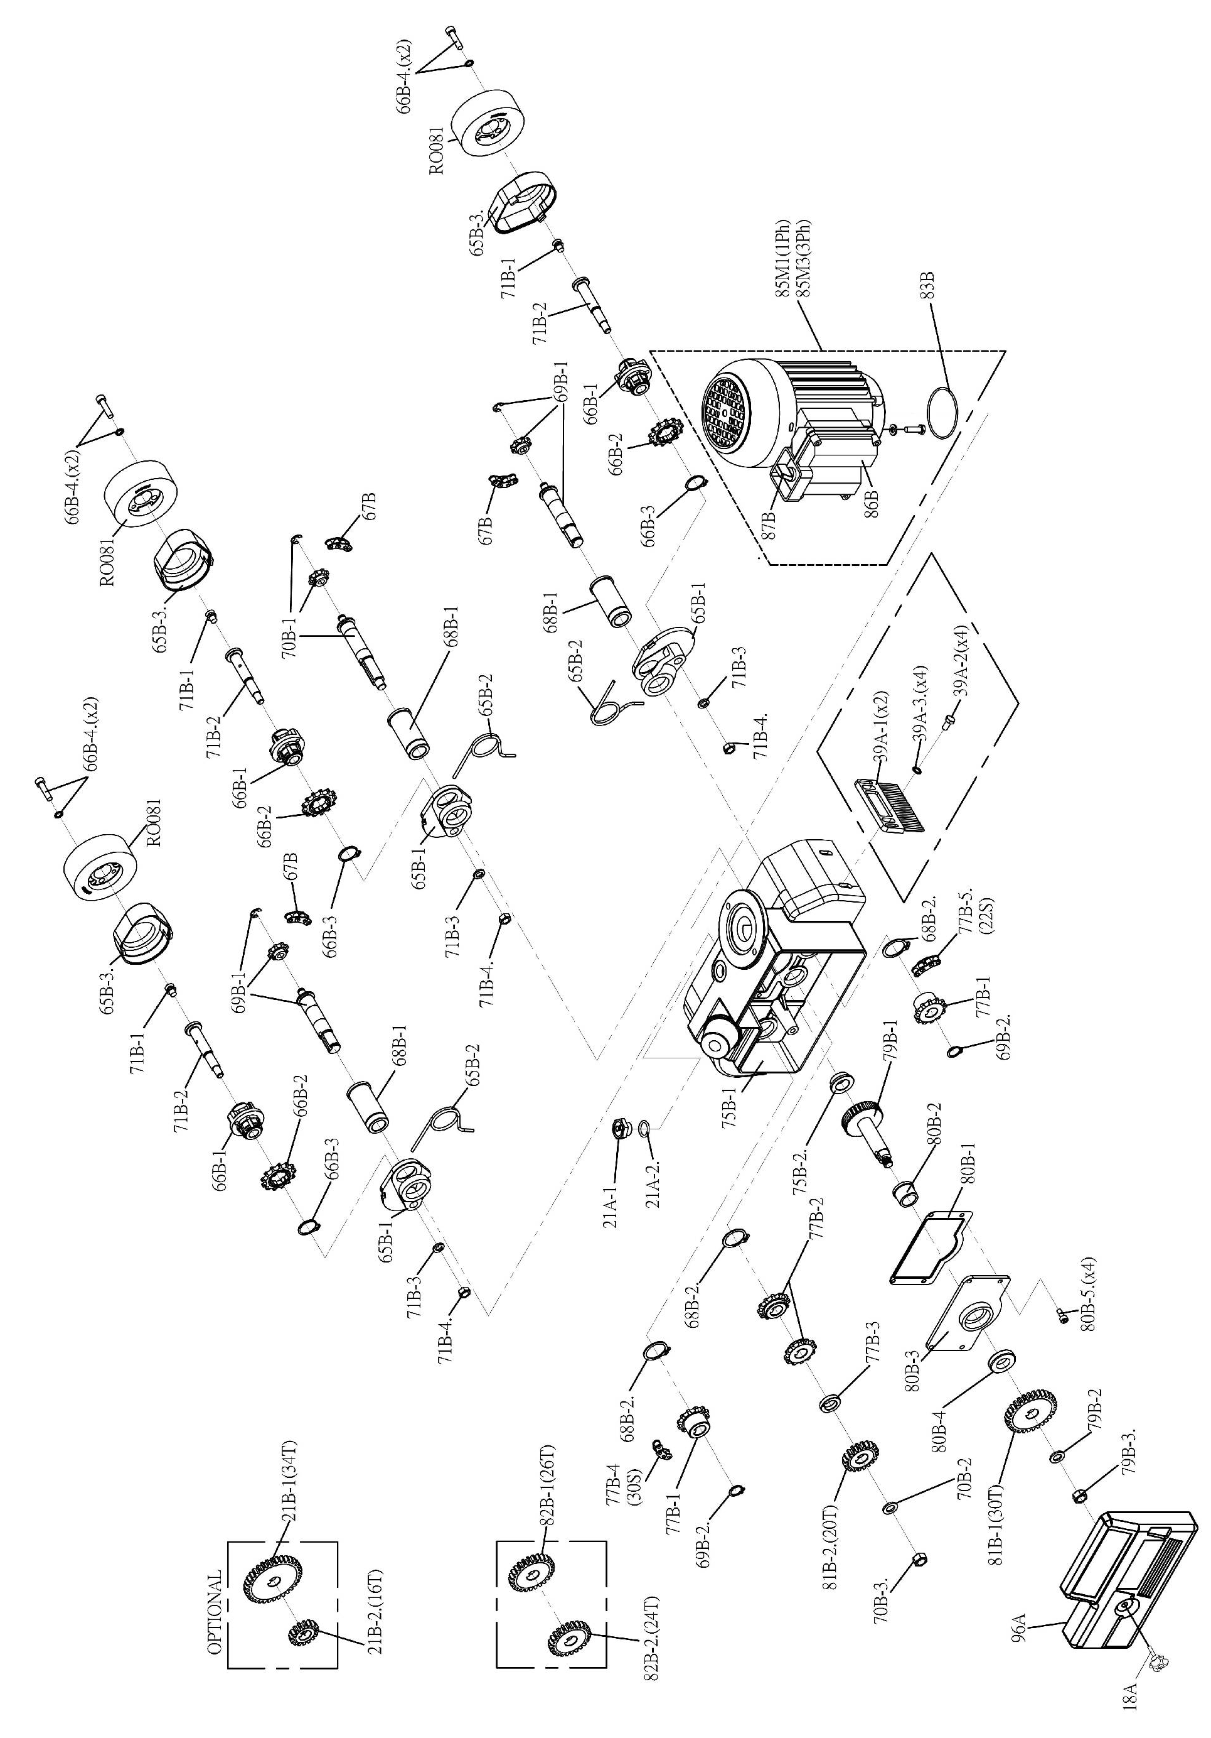
MODEL： JPF-2 HOUSING ASSEMBLY

